EVIDENCE IN SOCIAL MEDIA EXISTENCE

**WHATSAPP**

Whatsapp number 0728994824

Username Tim

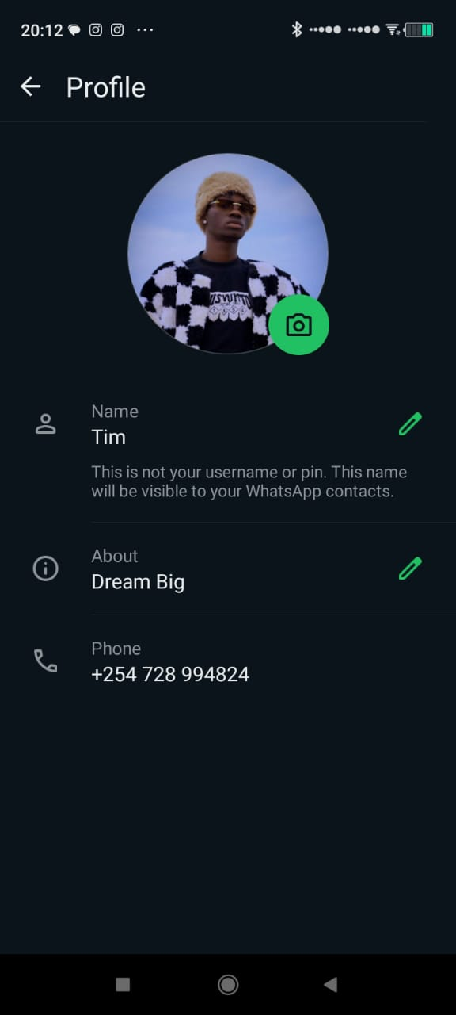

**TIKTOK**

Username: @2x_timmy

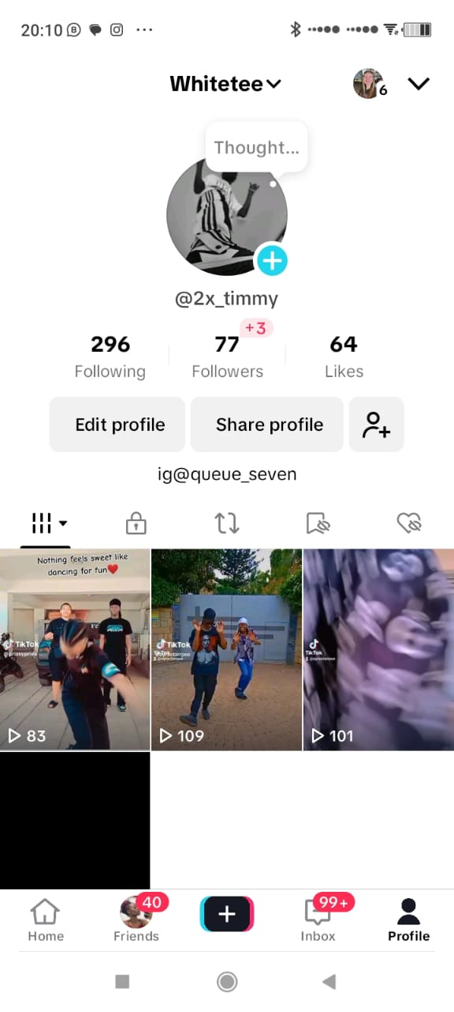

**LINKEDIN**

